**Lesson 7 Practice Hands-On**

**Directions**

For your Lesson 7 Practice Hands-On, you will be practicing your new Routing skills. This Hands-On will not be graded, but we encourage you to complete it. The best way to become a great programmer is to practice! Once you have submitted your project, you will be able to access the solution on the next page.

**Caution!**

Before continuing, if you have an Angular application running, be sure to stop the server using Ctrl + C!

**Setup**

1. Start off by downloading the starter project and unzipping it. The starter project will be in a folder named angular-L7-handson.

[**Starter Project**](https://repo.exeterlms.com/documents/V2/Angular2/V2/angular-L7-handson.zip)

1. After unzipping, move the starter project folder to the FEFAngular folder located inside the FullStackWeb folder and rename it from angular-L7-handson to L07HandsOn.
2. Open up your terminal/command prompt.
3. Run the following to navigate to your Desktop
4. cd Desktop
5. Next, navigate to the FullStackWeb directory in your terminal.
6. cd FullStackWeb
7. Then, navigate to the FEFAngular directory in your terminal.
8. cd FEFAngular
9. Navigate into the L07HandsOn directory:
10. cd L07HandsOn
11. Now that you are in the L07HandsOn directory, run the following:
12. npm install
13. Next, run the following:
14. npm install typescript@2.8 --save-dev

**Requirements**

For this project, you will be adding Routing to a provided project.

**Step 1**

* Open the L07HandsOn project in VS Code and start the server with ng serve --open. You will only see the following:

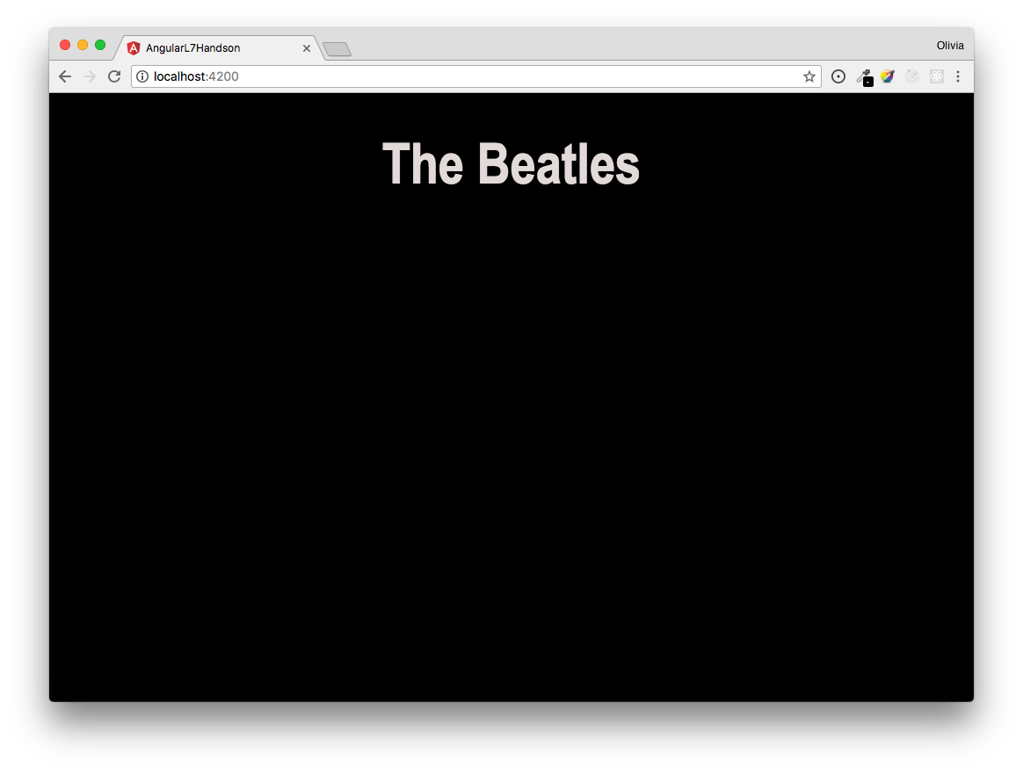

* Run the necessary command using Angular's CLI tool that will install Angular routing at the base level of your project.

**Hint!** This command is located towards the beginning of this lesson.

* Currently, this project has 3 separate components which *are not* being rendered. Within the routing module, add the necessary code for routing through the following components:
  + HomeComponent
  + AboutComponent
  + AlbumsComponent
* Within the routing module, add the necessary values within the imports and exports arrays.
* Each of the above components have either images, information, or both. Add a navigation bar to the base component's HTML file which routes to each of the above components using the designated path.

**Hint!** The path was determined during the first bullet point.

* Style the navigation bar to your liking.
* Lastly, be sure to add the necessary component to the base component's HTML to allow for the use of routing.

**Example**

When finished, your project should look similar to the following:

**Home** page:

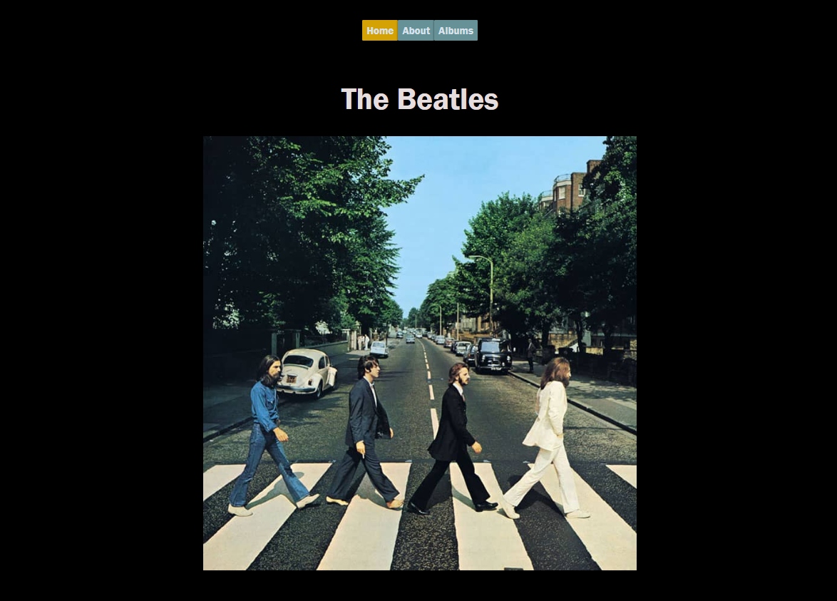

**About** page:

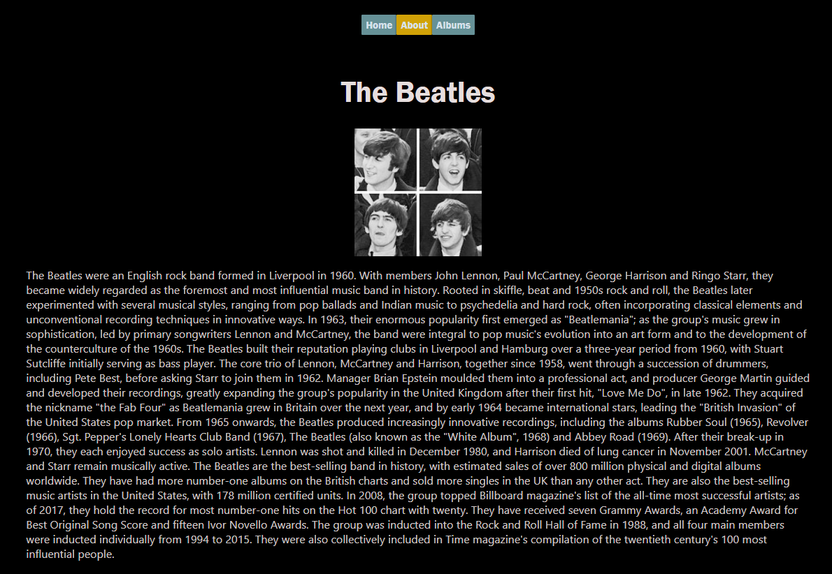

**Albums** page:

